THE CHECKER GAME

### Project Prototype

## https://upload.wikimedia.org/wikipedia/en/1/1f/Bahria_Uni.png

## Submitted to

Sir Naeem –Ur- Rehman

## Submitted by

Rabia Bashir

01-133132-144

BSE-6B

**Department of Software Engineering,**

Bahria University, Islamabad.

**Checker Game**

Purpose

The main purpose to choose this Game is to think in various direction and make different strategies according to different situations effectively and efficiently in short period of time. It increases the Capability of a person to think and make decisions and strategies in short interval of time to win the Game. It help in exploring various kind of strategies according to any critical situation and make decision according to it.

# Introduction

Each player begins the game with 12 pieces or checkers placed in the 3 rows closest to him or her. The main aim of this game is to remove all of your opponent's checkers from the board. Basic movement is to move a checker one space diagonally forward (left, right) .

# Objective

The objective of this project is to create Checker game in which player can make move diagonally and remove all the opponent's pieces so that opponent has no possible moves.

# Problem Description

1. **Setting Up the Object of Checkers**

The checkerboard has 64 alternating light (White) and dark (Black) squares. The game is played on the dark squares (i.e diagonally).

* **Simple** **Movement**

In simple movement the main aim is to move a simple checker or piece one space diagonally forward(left or right) if any diagonal is present .

* **Jumping**

In jumping ,if your opponent’s checkers or piece is on a forward diagonal(left, right) next to one of your checkers, and the next most space is empty, then your checker must jump over the opponent’s checker and remove opponents checker from the board and place itself in the next most available empty space and getting the point for it.

. Both players kings (red King and blue King) are allowed to make multiple jumps in both direction (Forward and Backward)

* **Crowning**

When one of your checkers or piece reaches to the last row of your opponent, it is crowned and becomes a “King”. Now both players Kings(Blue King and Red King) can move forward and Backward as well as Jump forward and Backward.

1. Games Rules
2. Checkers is played between two players. Each player starts the game with 12 colored discs. (One set of pieces is blue and the other is red.)
3. The board consists of 64 squares, alternating between 32 dark (Black) and 32 light squares (White).
4. Game can be played on alternative black squares only.
5. Each player places his or her pieces on the 12 dark squares closest to him or her.
6. Blue moves first and afterward Players then alternate the moves.
7. Simple Moves are allowed only on the dark squares, so pieces always move forward diagonally (i.e Blue move left down diagonally and right down diagonally wheras Red move left up diagonally and right up diagonally). Single pieces are always limited to forward moves (means only towards the opponent’s side).
8. When a jump is possible then the opponent pieces should be removed from the board and gaining a point against it.
9. When your piece reaches towards the opponent last row it is crowned and now your simple piece becomes a king.
10. Kings moves both diagonally forward and backward.
11. A player wins the game only when the opponent cannot make any possible move or because all of the opponent's pieces have been removed from the board and thus game come towards end showing a wining panel for the player piece.
12. Sound System for simple move as well as jump move.
13. Wining Panel for both players pieces

Project Main Flow

* 8x8 Game Board
* 24 Discs (12 of 2 Colors)
* 12 red pieces ,12 blue pieces
* Sound System for Game Playing
* Score Update Panel for red and blue pieces
* Game Scored Panel
* Game Wining Panel

# Methodology

The figure shows the main flow of game from start to end, while creating game we will use this methodology.

Block Diagram

Main Flow of our Program



1. Interface

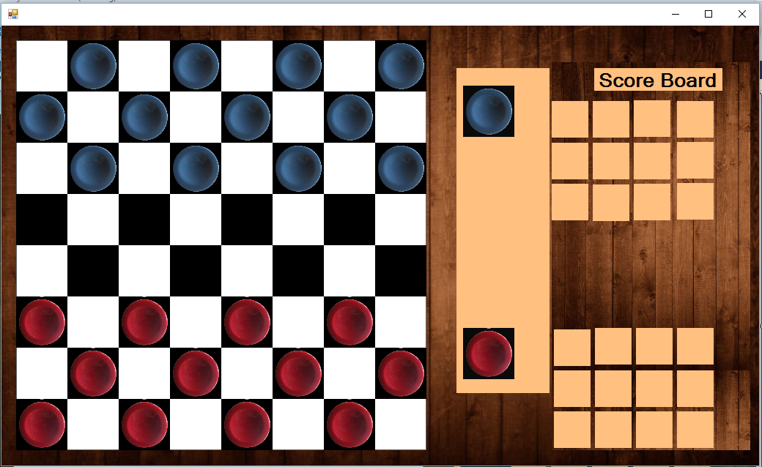

1. Use Case Diagram

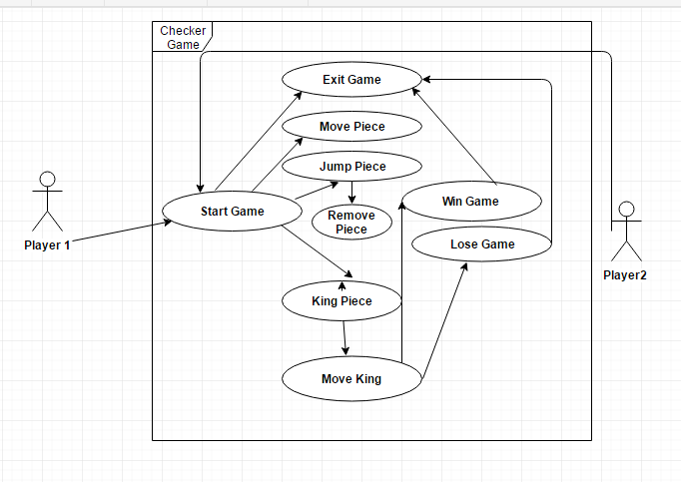

1. Class Diagram

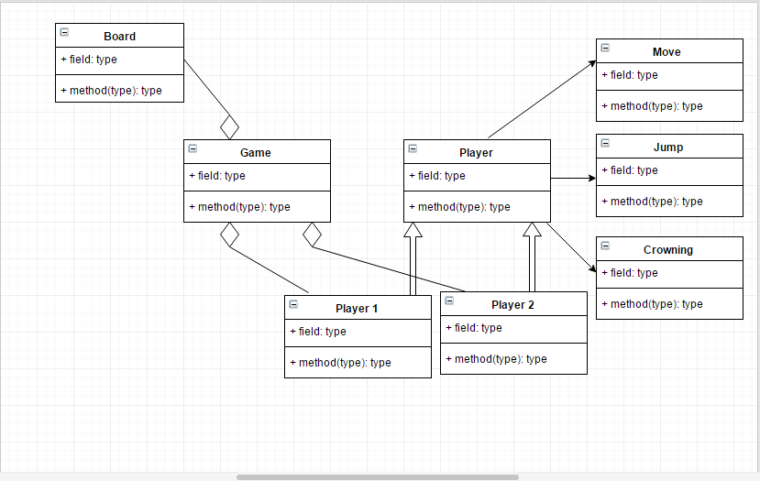

# Solution Application Areas

Checker is very interesting game and very fruitful for brain exercise because you can play in many ways, it will build your thinking strategy. The main target domain of this game is 10+ aged users. Sharp your mind and are good brain exercise.

# Tools/Technology

* Microsoft Visual Studio (Professional)2013

C# language

* CS Photoshop

8. C# Concepts to be Used

* Form
* Button
* Label
* Panel
* Images
* Picture Box
* Image Layout
* Sound Player

# 9. Milestones

This project will take 7- 8 weeks to complete.

10. Work Division

1st Week: Project Proposal + Project Prototype + Interface + Requirement Gathering.

2nd Week: Algorithm made+ Understanding the Rules of Checker Game

3rd Week: Implementation of Modules started + Understanding the Concept of Form Based Application+ Understanding the use of CS Photoshop.

4th Week: Algorithm implementation started for Player 1(Basic Moves, Jumps, Crowning).Update Score of Player 1

5th Week: Algorithm implementation started for Player 2(Basic Moves, Jumps, Crowning). Update Score of Player 2 .Wining Panel.

6th Week: Check all the Possibilities to be included (No bug or Error to be found).Fix the Bug or Error if any found.

7th Week: Check the overall functionality of Program, Modules interaction, and how they behave, Interface look.

Conclusion:The Outcome learning of this project from C# perspective is to understand the Form Based Application. Concepts and CS Photoshop Usage.